TABLE MAZE

Grade Level: 5, 6, 7, 8

Subject(s):

* Computer Science

Duration: Three 30-minute sessions

Description: This lesson introduces students to higher documentation skills using tables. Students create a table and use word processing functions to design a maze.

Goal: Students will develop competency in word processing skills, specifically the table feature in Microsoft Word.

Objectives:

1. Students will be able to use the table feature of Microsoft Word to construct a solvable maze.
2. Students will be able to incorporate clip art and WordArt into their mazes.

Materials:

* computers with Microsoft Word
* download the Table Maze Directions to your computer
* view Table Maze Directions in .pdf format

Table Maze Directions in .pdf format requires free Adobe Acrobat Reader.

Click the icon to obtain the free Reader.

Vocabulary:

1. table - Microsoft Word feature that allows the user to format a document.
2. border - Microsoft Word feature that creates line borders within or around a table.
3. merge cells - Microsoft Word feature that makes a large cell out of smaller cells.

Procedure:

[ Note: See Materials for the Table Maze Directions. The directions contain helpful diagrams for creating a maze. Below are general directions for completing the activity.]

Students begin by opening a new Word document. Students click on the Tables and Borders button to bring up the Tables and Borders toolbar. Using the Table menu button, each student inserts a table with 14 columns and 14 rows. Then students highlight the entire grid and double space the cells by going to: Format/Paragraph/Line Spacing (Double).

The words "Start" and "End" should be typed in the grid. For example, "Start" could be in the upper left cell and "End" could be in the lower right cell. Students create a path between the "Start" and "End" by using the Border icon to remove cell walls. (Optional for 6th grade or higher: use diagonal lines and line thickness to create chutes and ladders.)

Next, students select an area of the grid to insert a picture. First, an area of 4 or 9 cells should be highlighted. Then students merge these cells by selecting Table/Merge Cells. Now a clip art picture can be inserted into that space. Students should make sure that their cursor is in the newly created cell area. Then students can go to Insert/Picture/Clip Art to select a picture. When the picture is inserted it may not fit perfectly at first, so students may need to adjust the picture's size and proportion. Students can add other pieces of clip art, and they can construct additional paths to form dead ends.

Once the paths have been completed and all clip art images have been inserted, then students can use WordArt to add a title to their maze (using the Drawing toolbar). Students should also include their name somewhere on the page. To make sure the mazes are solvable, students can preview the mazes by using the Print Preview option under the File menu.

In closing, students print their mazes and turn them in. The teacher can make copies of each maze so that the students can solve each other's mazes. Also, copies of the mazes can be given to other students in the school (other elementary grade students).

Assessment: When students turn in their mazes, check to see that each maze is solvable. Each maze should have the student's name, a title, clip art, WordArt, and dead ends.

Special Comments: Many adults have problems using the table functions in Microsoft Word. This exercise is fun for the students and will ensure they are competent in using tables as they format future school work.

Step 1 Build a table 14x14 using table creation icon in Standard Toolbar.

Step 2 Double space cells using Format/Paragraph; choose Line Spacing/Double.

Step 3 Create a path between a Start and End point using the Border icon on the Formatting Toolbar to remove cell walls.

Start
End

Step 4 Choose a place to insert a picture (later Step 5) by highlighting an area of 4 or 9 cells and merge those cells by selecting Table/Merge Cells.

Start
End

Step 5a and 5b Choose a picture from ClipArt and insert it into the space you’ve created. Ensure your cursor is in the newly merged cell, then select Insert/Picture/ClipArt and insert the picture. The picture may not fit perfectly at first (see below), so be sure to adjust the size and proportion immediately to retain consistency in cell sizes throughout the maze (shown at bottom).

Start
5a) Note how one row is no longer uniform with the rest of the maze
End

Start |  |  |  |  |  |  |  |  |  | 5b) Adjusting the picture size will return the rows and columns to their original width and height

Step 6 Create additional paths to create dead ends in the picture you created.

Start
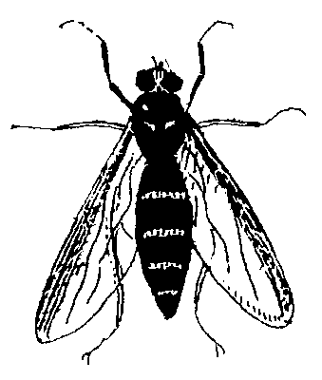
End
Step 7 Continue to carefully add paths and pictures, adjusting the details as you go to create a challenging maze for your friends.
Start
End
Step 8 Create a title for your completed maze using WordArt (using the Drawing Toolbar). And be sure to add your name before printing.

Start
End

